Print Spectrum Table Schema

- Go to Info Link | Table Directory Inquiry

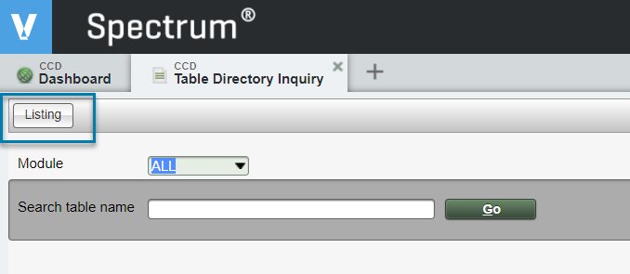

- Click Listing

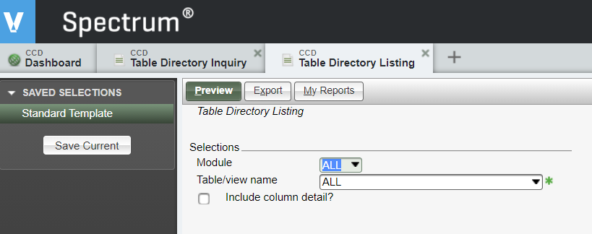

- Select the Module

- Click the Table/view name drop down

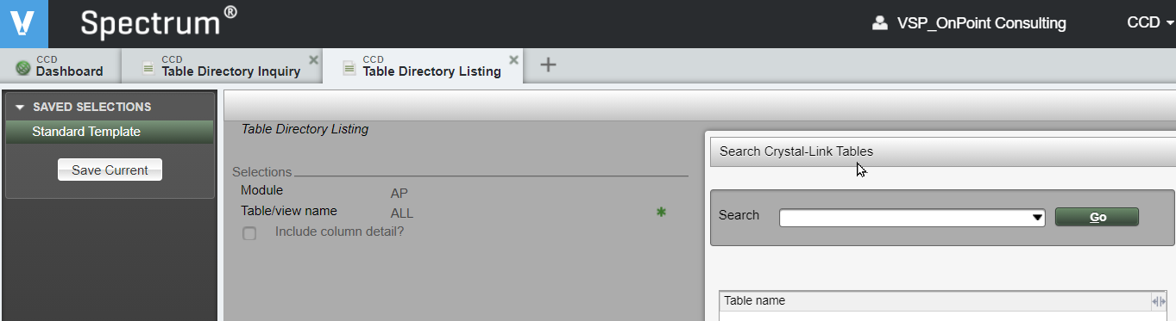

- Type part of the table name in the Search field

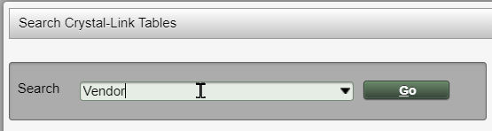

- Click Go

- Select the Table
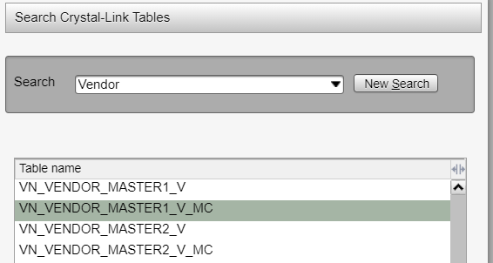

- Click OK

- Click “Include column detail?”

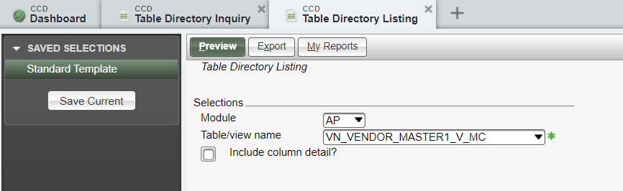

- Click Preview
